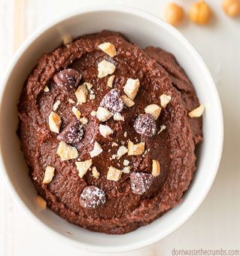**Chocolate Protein Dip**

**Ingredients:**

Makes 8 servings

1- 15 oz can garbanzo beans

3-4 tbsp maple syrup

¼ cup peanut butter (or any nut butter)

¼-½ tsp sea salt

4 tbsp unsweetened baking cocoa

2 tbsp water

chocolate chip (optional)

Nutritional info (per serving): Calories: 251, Fat: 7g, Protein: 11g, Carbohydrate: 38g, Fiber: 10g, Sodium: 150 mg, Potassium: 465 mg

**Directions:**

1. Combine all the ingredients except water in food processor
2. Puree until mixture is smooth, and add water to create desired consistency

Retrieved from: http://turniptheoven.com/magic-five-ingredient-chocolate-hummus/

Interested in learning more about nutrition and health? Call the Wellness Center at 255-4444 and schedule an appointment one of our dietitians, Alyssa Shrader or Merri Metcalfe or Yuka Sanui.