Turmeric Ginger Tea

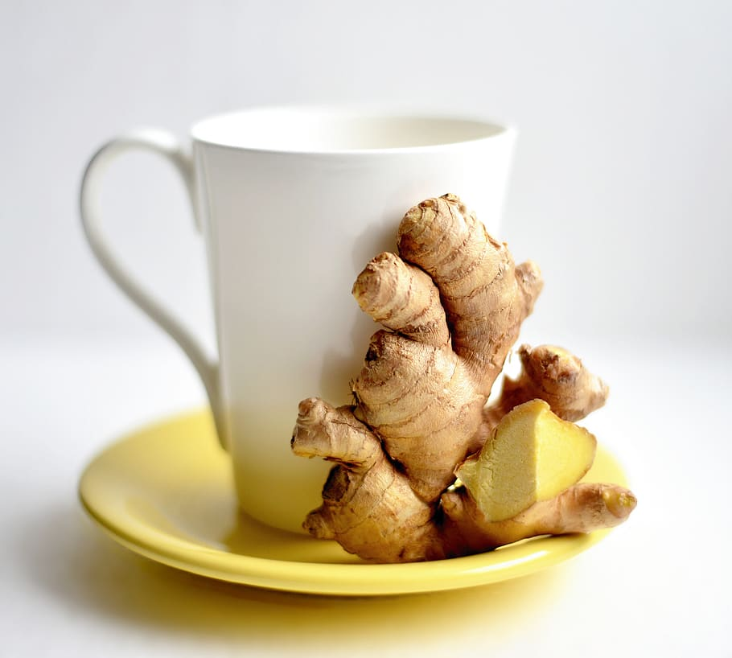
Ingredients:
4 servings

4 cups water
3-4 in pieces of fresh turmeric, thinly sliced
2 inch pieces of fresh ginger, thinly sliced
2 tbsp honey or agave syrup
Juice of ½ orange, lemon, or lime
A pinch of salt
A pinch of black pepper

Directions:
- Place ingredients in a medium pot.
- Bring to a boil.
- Reduce heat to low and let simmer for 5 minutes.
- Remove from heat and let cool
- Drink warm or let it cool and have a refreshing cold tea.

