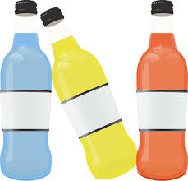
Sports Drinks

Ingredients:
1 serving

Ciderade (on cold days)
1 ¾ cup water
1 ¼ cup pure apple cider
¼ tsp cinnamon
1/8 + 1/16 teaspoon salt

Minty Pomegranate
2 cups brewer unsweet mint tea (store bought or made)
1 cup pomegranate juice
1 tbsp fresh lemon juice
1/8 tsp + 1/16 tsp salt.

Maple Orange
2 cups water
1 cup pulp free juice
2 tbsp pure maple syrup
1/8 tsp salt + 1/16 tsp salt

Directions:
- Combined all ingredients in a bottle and shake well.
- Enjoy!

A well-designed sports drink should include a mix a fluid, fast digesting carbohydrates and electrolytes to keep you going. These combos fill a 24oz or 3 cup bottle. No more than 5% carbohydrate concentration or help maximize stomach emptying and intestinal absorption. These are a little lower on salt, but you can always add more depending on how heavy of a salt sweater you are.

