Savory and Sweet Hand Pies

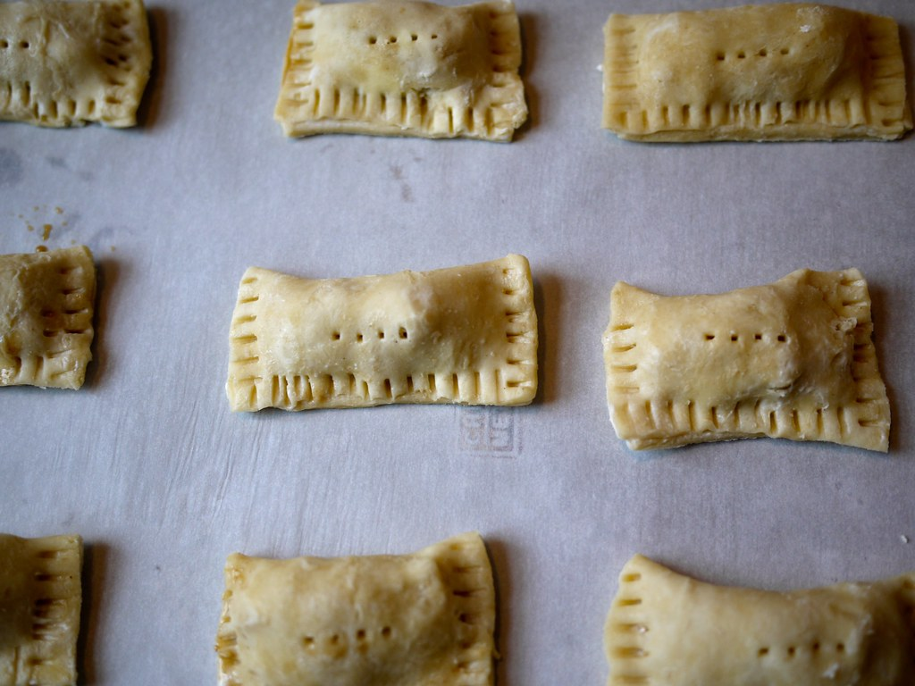
Ingredients:
8 servings

2 frozen pie shells, defrosted
1 egg

Nut Butter & Jelly
¼ cup nut/seed butter
¼ cup jelly of choice

Savory Apple Pie
1 cup grated mozzarella cheese
1 cup quartered cherry tomatoes

1/3 cup chopped fresh basil

Directions:
- Preheat oven to 375 degrees.
- Working with the pie shell one at a time flip shell and flatten. Make sure there are no cracks, seal if there are cracks with moistened fingers.
- Slice shell in 4 equal triangles.
- Whisky egg with 1 tbsp of water.
- Place pie fillings in middle of shell. Don’t over stuff.
- Brush edges with egg wash and fold over each triangle to form a smaller triangle.
- Seal edges with a fork.
- Bake for 15 mins or until golden brown.

