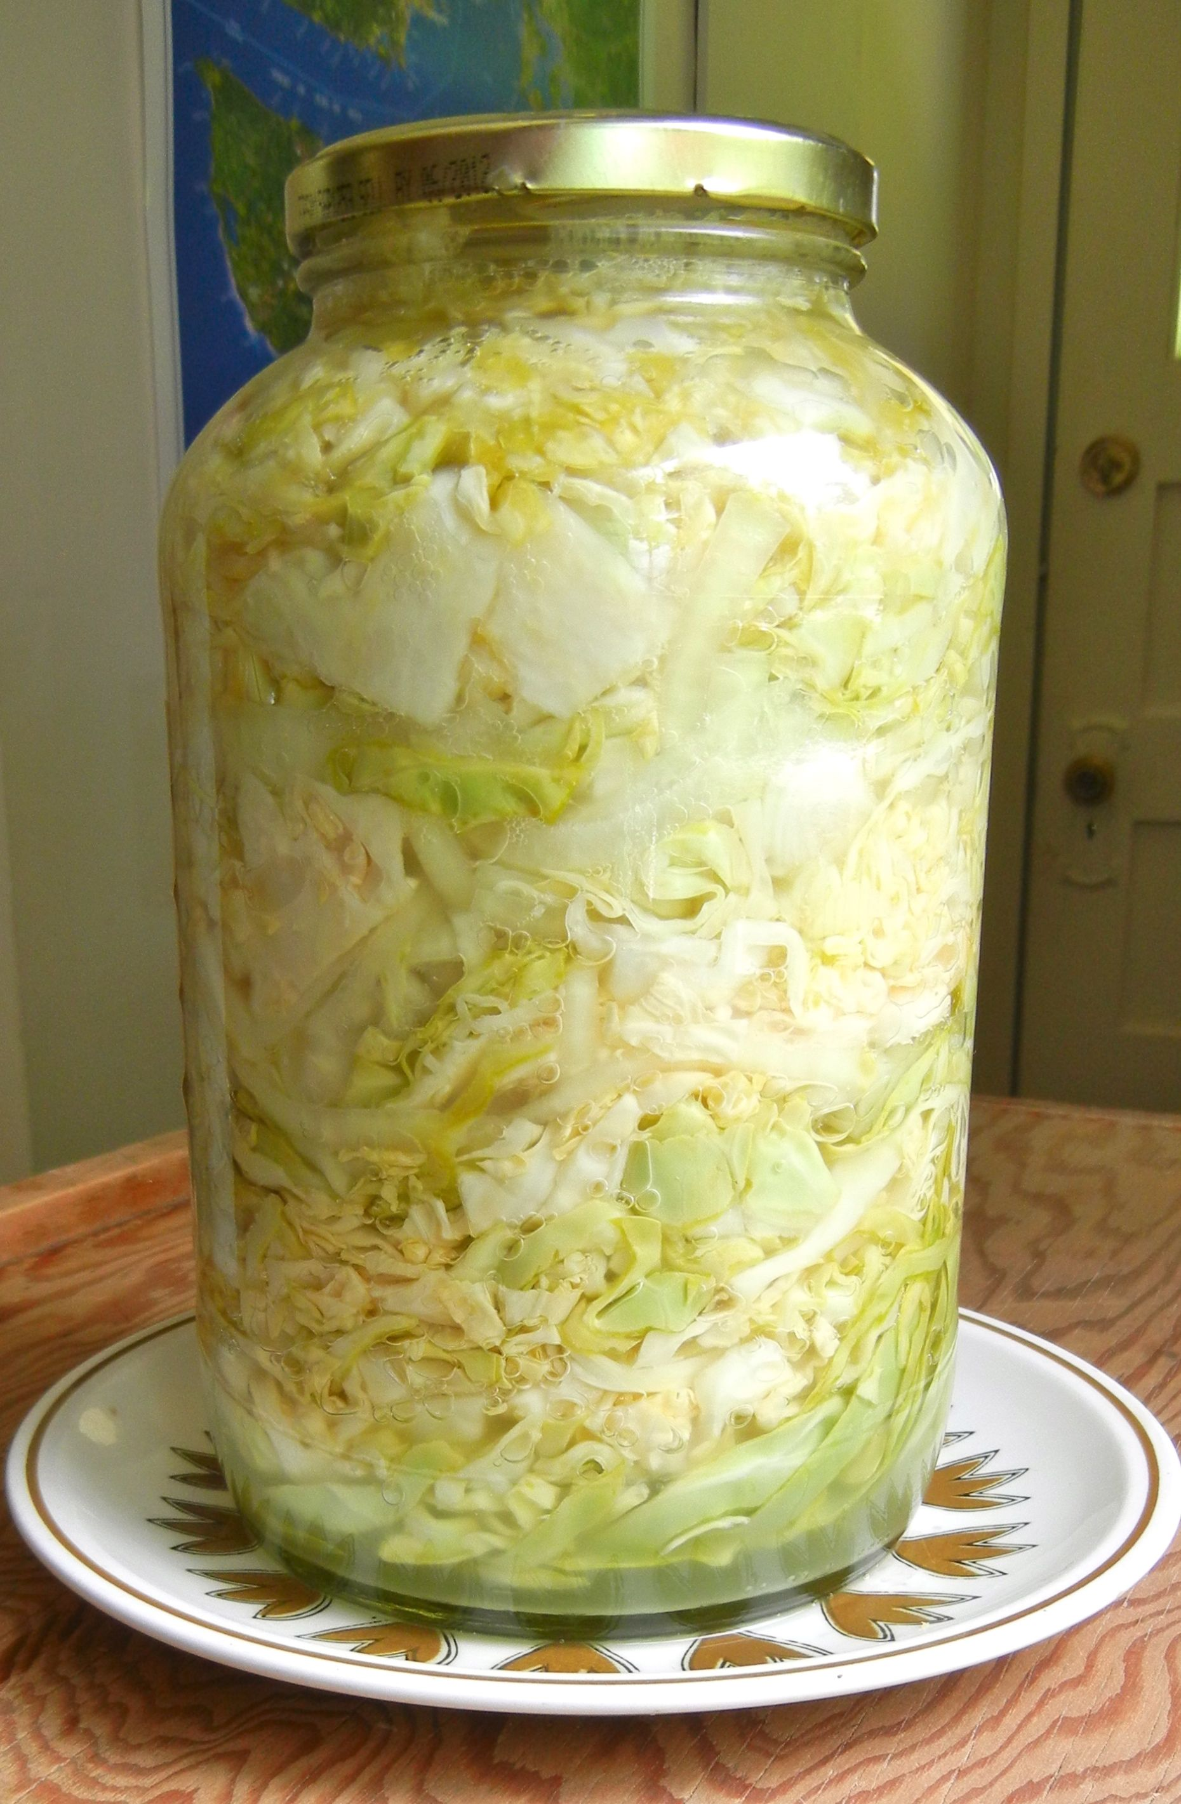
Make Your Own Sauerkraut

Ingredients:
½ small head cabbage, shredded (roughly 4 cups or 11 oz)
1 carrot (optional)
2 tsp of salt

Directions:

- Clean cabbage and discard any brown or unwanted leafs.
- Chop cabbage into desired size, should be strips or use a food processor.
- In a large bowl, mix cabbage with the salt. Let the mixture rest for 15-20 minutes to let the salt start drawing moisture out of the cabbage. (To speed up the process, you can massage the cabbage and salt together for 5-10 minutes.)
- Wash a quart mason jar well with hot soapy water. Pack the salted cabbage mixture (and any juices) into the clean jar. Pound the cabbage with the back end of a wooden spoon to pack it tightly and remove any air pockets.
- Place a quart-sized Ziploc bag into the jar (use one that you know holds a tight seal fill the bag with water and seal the bag. This will act as a weight and help to keep all the cabbage submerged – optional). Cover the jar with the lid.
- Check the sauerkraut after 24 hours. If the cabbage is not entirely submerged in brine, add a saltwater mixture of 1 tsp salt to 1 cup water to the cabbage, just until it is submerged.
- Place the jar somewhere out of the way, in a fridge, or dark area away from direct sunlight, to ferment. Fermentation can take 1-3 weeks, depending on the temperature and your desired flavor
- Taste your sauerkraut every few days, and once you like the flavor store in fridge.

Tips:
MAKE SURE YOU OPEN AND CLOSE THE LID EVERY DAY TO RELEASE AIR BUILDUP.
While the sauerkraut is fermenting, you may notice it bubbling and foaming. This is normal and can be skimmed off before you refrigerate your sauerkraut.

If at any point your sauerkraut starts to turn a strange color or get fuzzy, your preparation probably was not as clean as you thought. You'll need to throw away this batch and start over.

Store in refrigerator for up to 1 week.

