Recovery Toast

Ingredients:
Each type makes 4 servings, or gets placed on 4 slices of toast

Avo-Banana
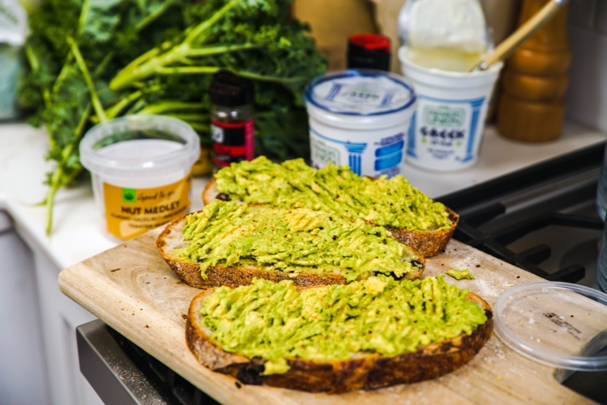
1 ripe avocado mashed
1 small ripe banana mashed
½ juice of lime
¼ tsp chili powder
1/8 tsp salt

Peachy
1 cup reduced-fat ricotta cheese
2 tbsp pesto sauce
2 peaches sliced
¼ cup sliced almonds or nut of choice

Beany
1 cup refried beans
1 avocado sliced
1 cup peach or mango sliced
2 oz diced feta
Lime juice to taste

Directions:
- Stir the base ingredients together (cheese, spices, mashed ingredients)
- Layer on toast of choice.
- Place fruit on top and enjoy!

