Pumpkin Kale Pizza
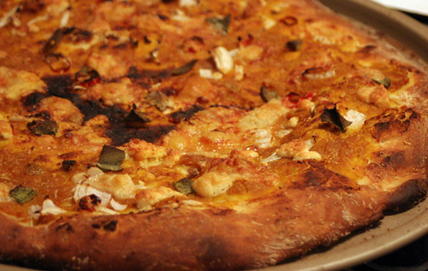

Ingredients:
Yield 1 pizza, 2 slices per serving

1 chicken sausage
1 bunch of kale
2 cloves of garlic (minced)
¼ can pumpkin
3 tbsp pumpkin seeds
½ cup shredded mozzarella
1 pizza crust, homemade or store bought.

Tip: try goat cheese or feta for a different taste!

Directions:

- Preheat oven to 400°F.
- Roughly chop kale and chicken sausage.
- Cook chicken sausage in a pan on the stovetop. Set aside when cooked.
- Massage kale, and then place in pan on stove. Cook kale with minced garlic 2-3minutes or until slightly wilted. Removed from stove.
- Spread pumpkin over pizza crust, add kale, sausage, and cheese.
- Bake pizza until crust is golden brown on the edges.
- Cool and enjoy!

Store in refrigerator for up to 1 week and reheat in microwave.

Interested in learning more about nutrition and health? Call the Wellness Center at 255-4444 and schedule an appointment one of our dietitians.

