Pineapple And Pepper Kabobs

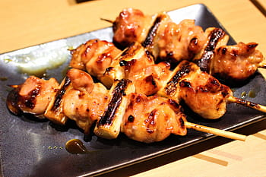
Ingredients:
10 Kabobs

2/3 cup barbecue sauce
2/3 cup teriyaki sauce
3 cloves garlic, minced
1 tablespoon freshly grated ginger
2 pounds boneless, skinless chicken breasts
2 cups fresh pineapple chunks
1 red bell pepper, cut into 1 1/2-inch pieces
1 white onion, cut into 1 1/2-inch pieces
2 tablespoons olive oil
Pepper for taste

Tip: Vegetarian? Replace chicken with extra firm tofu, drained and sliced into large chunks.

Directions:
- Preheat oven to 450 degrees, and place skewers in a bowl of water to soak.
- Mix barbecue sauce, teriyaki sauce, garlic and ginger in a bowl. Reserve 1/2 cup and set aside.
- Chop chicken up into square pieces and place in BBQ mixture, make sure chicken is covered completely and set aside.
- Chop onion, pepper, and pineapple into slices and squares.
- Alternate the vegetables, fruit, and chicken on the skewer, making ~10 skewers.
- Place on two baking sheets lined with aluminum foil or spray, brush with remaining sauce and cook for 25-30mins, rotating skewers until fully cooked.
- Enjoy! You can keep extra in the refrigerator in a sealed container for up to three days!

