HOMEMADE PIZZA SAUCE

Ingredients:
Yields 2 cups

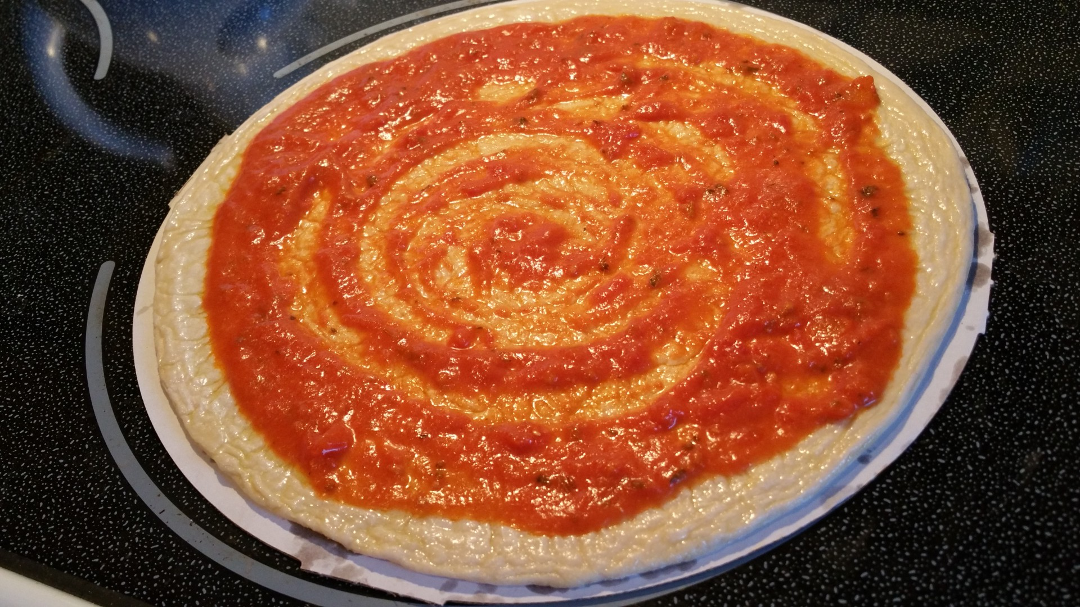

1 tablespoon olive oil
1 tablespoon minced garlic
1 teaspoon dried oregano or
2 cans (14.5oz) diced tomatoes (undrained)
or 2 pounds diced fresh tomatoes
1 teaspoon granulated sugar/honey/agave
1/4 teaspoon red pepper flakes
1/2 teaspoon salt
Black pepper to taste

Directions:
- Dice garlic and tomatoes.
- In a medium saucepan over low heat, warm the olive oil.
- Add the garlic and cook, stirring for about a minute. If you’re using dried oregano, add that along with the garlic. If you’re using fresh, add it to the sauce at the end of the cooking time*****
- Increase the heat to medium. Add the tomatoes, sugar, red pepper flakes, salt, and black pepper.
- Leave over medium heat, stirring occasionally, until boiling. Reduce heat to low for a nice simmer.
- Simmer uncovered for 90 minutes or until desired.
- Stir in fresh oregano, if using now*****
- Allow the sauce to cool to a safe temperature and then, using an immersion blender blend sauce.
- Use on pizza, pasta, and enjoy and use within 5 days or freeze!
Interested in learning more about nutrition and health? Call the Wellness Center at 255-4444 and schedule an appointment one of our dietitians.

