Whole Grain Pizza Crust

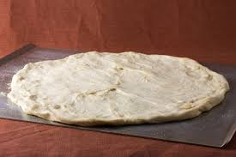
Ingredients:
1 crust

1 (.25 ounce) package active dry yeast
1 teaspoon sugar
1 cup warm water (110 degrees F/45 degrees C)
1 1/2 cups wheat flour
1 cup white flour
2 tablespoons olive oil
1 teaspoon salt

Tips: Add some of your favorite seasonings like garlic, rosemary, or thyme to your crust!

Directions:

- Preheat oven to 450°F.
- In a medium bowl, dissolve yeast, sugar, in warm water. Let stand until creamy, around 10 minutes.
- Stir in flour, salt and oil. Mix until smooth. Let rest for 5 minutes in a warm area.
- Knead dough out onto a lightly floured surface and pat or roll into a round ball.
- Flatten out the dough.
- Transfer crust to a lightly greased pizza pan. Spread sauce and toppings on dough.
- Bake in preheated oven for 15 to 20 minutes, or until golden brown.
- Let cool for 5 minutes and enjoy!
Have extra dough? Freeze it for another day!

Interested in learning more about nutrition and health? Call the Wellness Center at 255-4444 and schedule an appointment one of our dietitians.

