HOMEMADE PESTO SAUCE
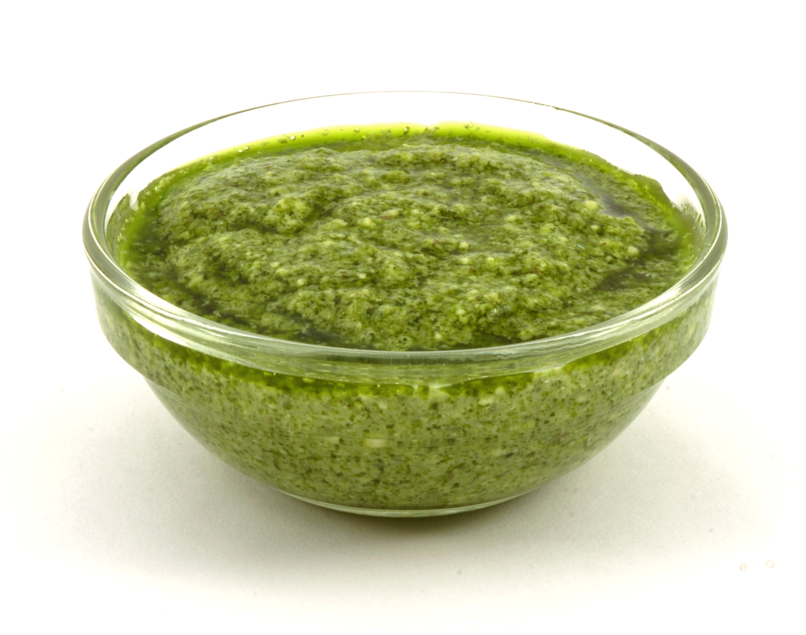

Ingredients:
Yields 2 cups

4 cloves garlic, crushed
6 ounces (2 healthy bunches/about 6 cups gently packed)
basil leaves, or any other green
1/2 cup raw pine nuts
1/4 teaspoon salt
1/4 cup extra-virgin olive oil
1/2 cup grated Parmesan cheese, or any other hard cheese

Directions:

- Place garlic in a food processor and pulse 5 to 6 times until roughly chopped
- Add about half of the basil to food processor and blend 5 to 6 times until the basil is roughly chopped.
- Add the pine nuts, followed by the remaining basil leaves. Pulse 10 to 12 times into a rough paste.
- Add the olive oil and cheese and blend into a fine, rough paste. Do not stream in the oil as other recipes instruct. Instead add the oil and cheese and pulse until just combined. The pesto should not be smooth but a rather irregularly paste.
- Store in refrigerator for up to 1 week and reheat in microwave.

Interested in learning more about nutrition and health? Call the Wellness Center at 255-4444 and schedule an appointment one of our dietitians.

