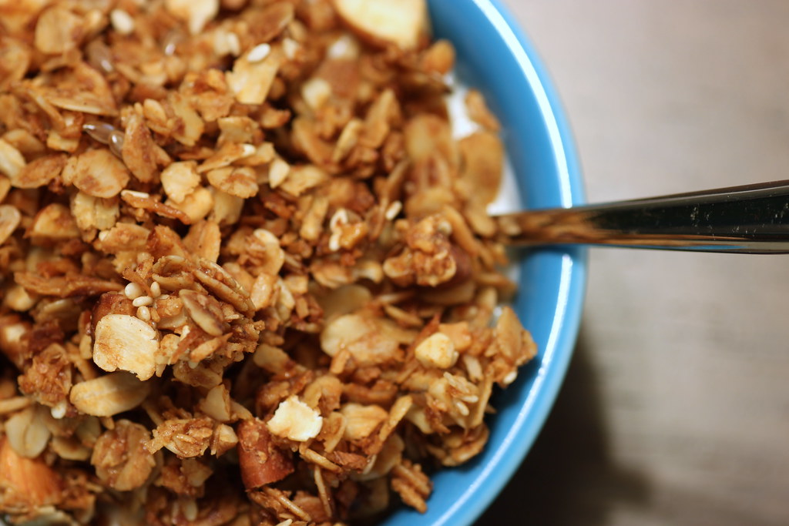

Make Your Own Granola

Ingredients:
2 cups of rolled oats
2 tablespoons of brown sugar
½ teaspoon of ground cinnamon
¼ teaspoon of salt
⅓ cup of honey
3 tablespoons of coconut oil
½ teaspoon of vanilla extract
½ cup of chopped nuts, dried fruit, or seeds (optional)

Directions:
- Heat coconut oil and honey in a large pan over medium heat
- Add oats, sugar, cinnamon, salt, honey and vanilla extract into pan.
- Stir constantly for 3-4 minutes.
- Stir in nuts, dried fruit or seeds if desired.
- Have as a breakfast with milk, a snack or add to yogurt with fresh berries to have a parfait!

