Healthy Homemade Potato Salad

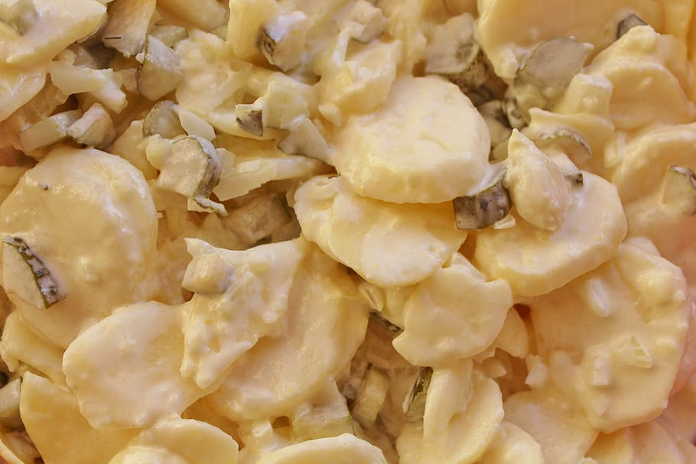
Ingredients:
6 servings

6 medium potatoes, quartered
3 tablespoons apple cider vinegar
2 large celery stalks diced
6 green onions diced
1 1/2 cups plain Greek yogurt
1 tablespoon mustard
salt and black pepper for taste
1 can chick peas, drained and rinsed

Additional Options: paprika, cilantro, jalapeno, spicy peppers, or your favorite BBQ spices!

Directions:
- Bring potatoes to a boil in large pot of cold water on medium heat with a dash of salt and cook for 10-15 minutes or until the potatoes are easily pierced with a knife. Drain and set aside.
- Dice the celery and green onions.
- Drain and rinse chick peas and add to celery and green onions.
- Mix vegetables with Greek yogurt, yellow mustard, salt and pepper until fully covered.
- Chop cooled potatoes into small bitesize pieces when cool and add to dressing mixture.
- Chill or enjoy right away!

Tips: Add your favorite protein to this side like egg or chicken instead of chick peas! Or roast our chick peas in a pan prior to mixing in.

