Homemade Salsa
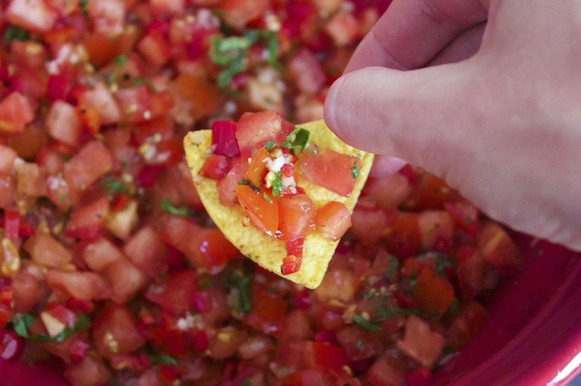
Ingredients: 8 servings

3 cups of cherry tomatoes
2 tomatillos
1-2 jalapenos
1/2 cup red or white onion
juice of 1-2 limes
4 cloves garlic
1 tablespoon olive oil
1/2 teaspoon ground cumin
1 teaspoon sea salt & black pepper

Directions:
- In the oven on broil, char all ingredients except the garlic and cherry tomatoes for 5-8 minutes or until all the ingredients have a nice black char to them.
- While items are cooking pulse the cherry tomatoes in a food processor to break them down and strain the excess liquid from the tomatoes using a fine mesh strainer, discarding the excess water from the tomatoes.
- Put all the ingredients from the oven and the strained tomatoes and garlic, in a food processor and pulse to combine. The longer you blend the thinner the salsa.
- Season sea salt and lemon juice to taste
- Enjoy!

Keep leftovers in the fridge for up to a week or freeze for 3-6 months.

