Homemade Energy Goo

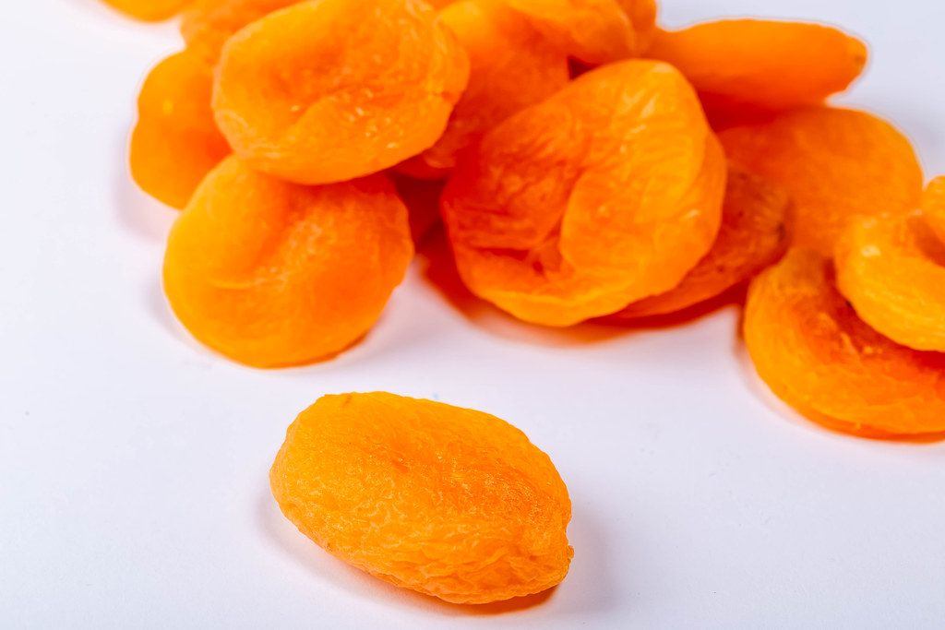
Ingredients:
2 portions

1/3 cup dried apricots
1 cup water

2 tablespoons maple syrup
1/4 teaspoon salt

Per portion: 118 calories; 1 g protein; 0 g fat; 30 g carbohydrates; 1 g fiber.

Directions:
- Place the apricots and water in a small saucepan.
- Bring to a boil, then reduce the heat and simmer for 10-15 minutes until the fruit is very soft.
- Add the maple syrup and salt, then puree using a food processor or hand blender. Add as much water as needed to create a more liquid texture. Leave to cool.
- Transfer to a flexible container that can be used during your workouts and competitions

