Homemade Coleslaw
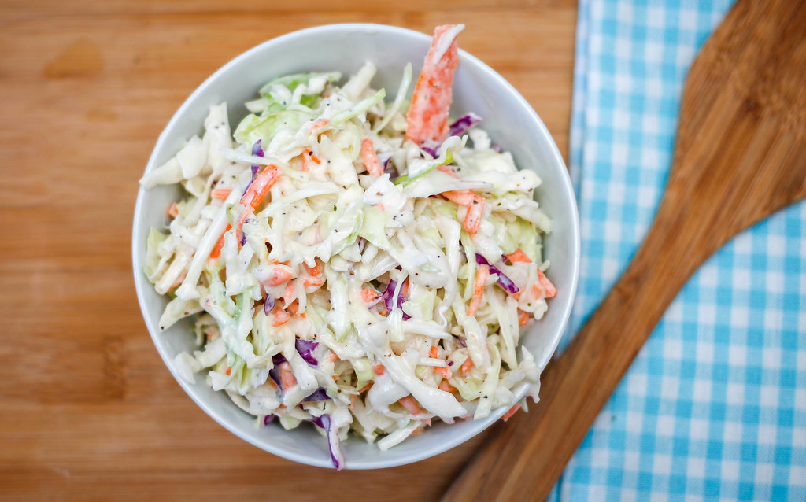
Ingredients:
6 servings

1 large carrot, grated
2 large cabbage heads (1 purple 1 green)
3/4 cup whole plain Greek yogurt
3 tbsp apple cider vinegar
1 tbsp honey or maple syrup
3 tbsp mustard
2 tsp lime or lemon juice
Salt and pepper, to taste

Directions:
- In a bowl, mix all ingredients together except for carrot and cabbage.
- Shred carrot and coleslaw using a grader. Chop carrot and cabbage thin if you do not have a grader.
- Place shredded vegetables into a large blow and gently stir in dressing.
- Let coleslaw sit for 5 minutes in the refrigerator to allow flavors to settle.
- Enjoy!

Tips: Need it in a hurry? Just use a bag of shredded cabbage and carrots instead.
Have extra? Place on top of burgers or sandwiches instead of just as a side!

