Homemade Baked Chips
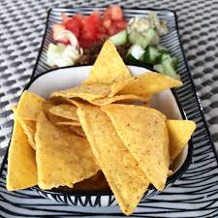
Ingredients:
4-6 servings

1 package of corn tortillas
1 tbsp oil
3 tbsp lime or lemon juice
1 tsp salt (for taste)

Add optional seasonings like 1 tsp cumin, chili powder, cayenne pepper, black pepper, red pepper flakes, anything you like on a chip!

Directions:
- Preheat oven to 350 degrees.
- Spray or use some oil on the sheet tray to make sure chips do not stick.
- Mix 2 tablespoons of oil, 1 tablespoon of lime juice together, and all dry seasonings together.
- Brush oil on one tortilla, making sure to cover the entire surface. Stack another tortilla on top and brush on oil mixture. Continue until you get have about 7 or 8 tortillas in a stack.
- Cut tortillas in half. Cut each half into small triangles.
- Place tortillas on the baking sheet and bake for 8-12 minutes.
- Let chips cool before serving and enjoy with your favorite dip!

Tip: Store chips in an airtight container. They should stay crispy for 1 to 2 weeks.

