Healthy Spinach Dip

Ingredients:
- 8 oz plain Greek yogurt
8 oz Greek cream cheese

- 1 10 oz. package frozen chopped spinach
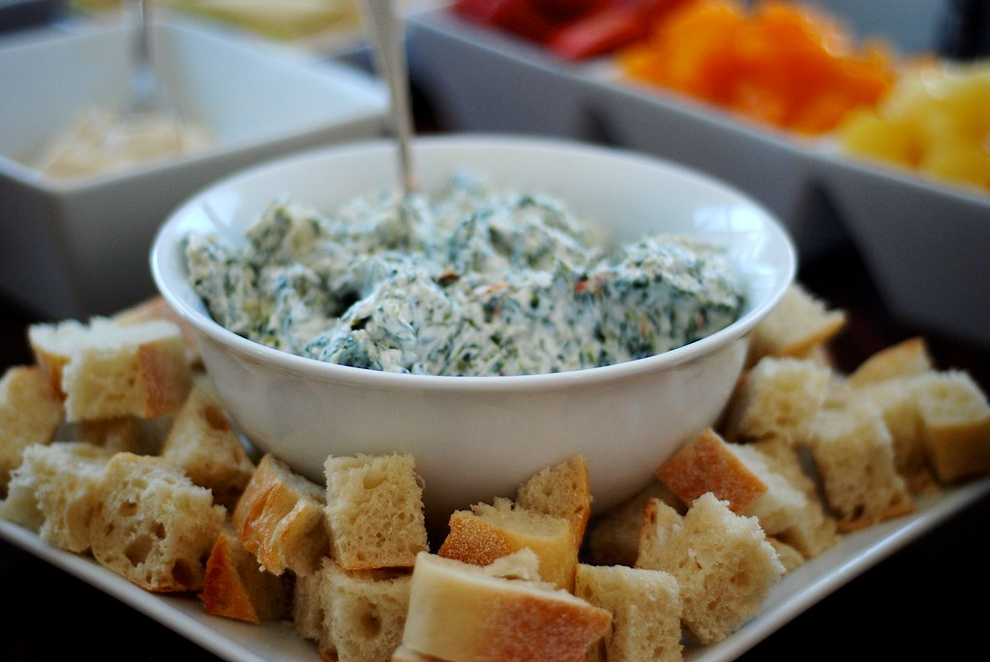
- ½ cup chopped red bell pepper
- ⅓ cup chopped scallions
- 2 cloves crushed garlic
- Red pepper flakes to taste

Instructions:
- Thaw spinach and press water out.
- In a medium or large bowl mix together yogurt, cream cheese, red bell pepper, scallions, and garlic until well blended.
- Add red pepper flakes to taste
- Serve with crackers, celery, carrots, peppers, etc.

