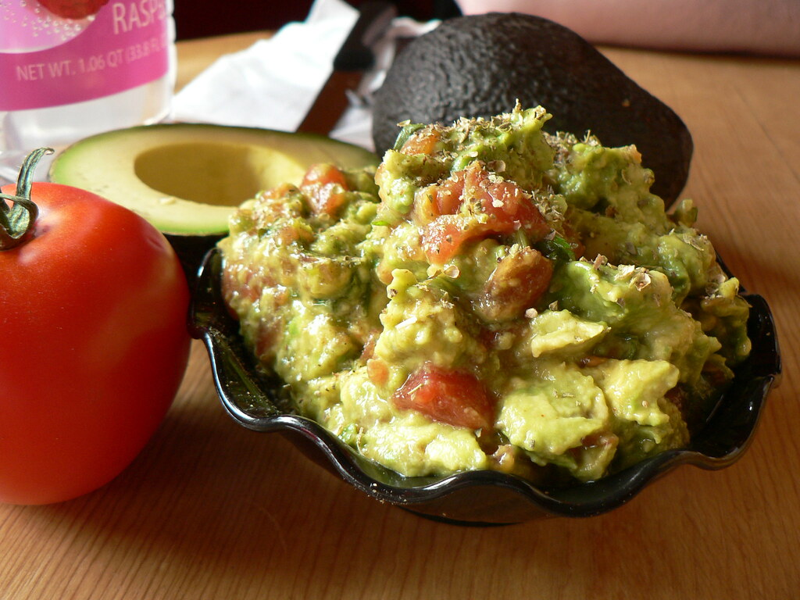

Guacamole

Ingredients:
Makes 4 servings:
- 3 ripe avocados
- Juice of 1 lime or lemon
- ½ cup of diced onion
- 1-2 roma tomatoes, diced
- Salt and pepper to taste

Directions:
- Scoop out avocado into a mixing bowl and mash.
- Add diced onions and roma tomatoes and mix
- Squeeze lemon or lime juice and add salt and pepper and mix.
- Enjoy! Experiment with other herbs and spices such as garlic, cayenne pepper or cilantro

