Make You Own Herbal Tea

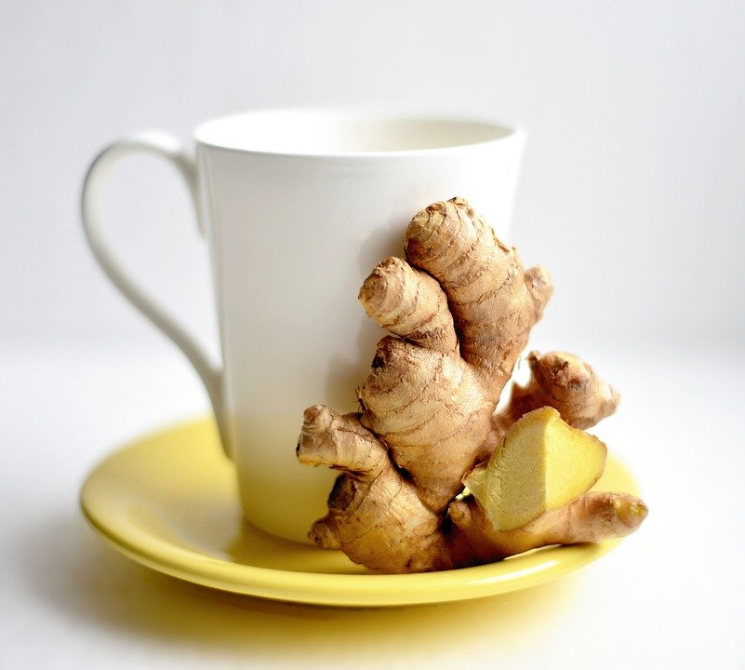

Ingredients:
2 cups water
1/2 teaspoon ground turmeric
1/2 teaspoon chopped fresh ginger
1/2 teaspoon ground cinnamon (optional)
1 pinch black pepper (optional)
1 tablespoon honey or maple syrup
1 lemon wedge

Directions:

- Grate fresh ginger
- Bring water to a boil in a small saucepan; add turmeric, ginger, and cinnamon.
- Reduce heat to medium-low and simmer for 10 minutes.
- Strain tea into a large glass; add honey and lemon wedge.
- Enjoy!

Black pepper helps with the bioavailability of the turmeric, meaning you absorb more!

