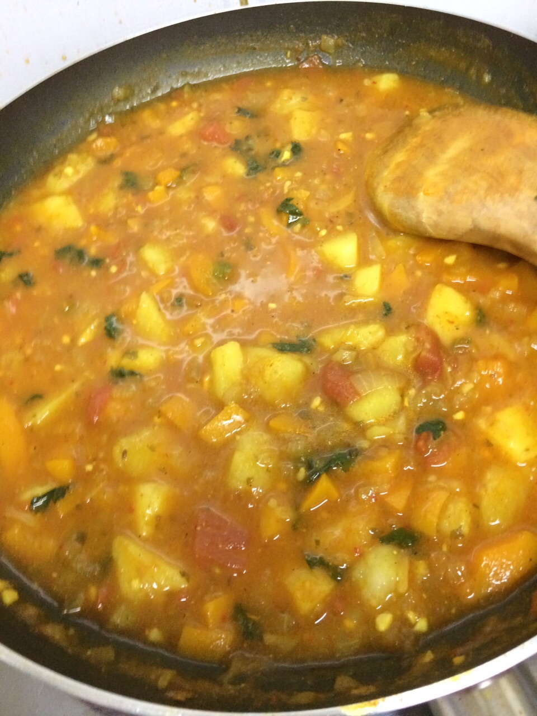
Easy Vegetarian Curry

Ingredients:
4-6 servings

2 cans of chickpeas
2 sweet potatoes
1 onion
½ cup coconut milk (unsweetened)
½ cup vegetable stock
3 tablespoons curry powder
15 oz can tomato sauce
1 tsp cumin and 1 tsp salt
1 cup frozen green peas (add last 10 minutes)
½ cup cashews (optional)

Add optional seasonings like cayenne pepper, black pepper, salt, or cilantro.

Directions:
- Prepare all vegetables as stated above. Chop the onion into thin slices, peel and dice 2 potatoes and place in a bowl.
- In the bottom of the slow cooker mix together coconut milk, broth, and selected seasonings.
- Place vegetables and chickpeas into slow cooker and evenly coat with sauce mixture.
- Cook on low for 8 hours or high for 4 hours.
- Place cashews and peas in slow cooker 10 minutes before serving
- Serve over whole grain rice and enjoy!

Tips:
YOU can use other milk products instead of coconut milk for a different taste/texture. Not Vegetarian? Add chicken and use cauliflower and chicken broth! Add more vegetables like red peppers too!

