Classic Hummus

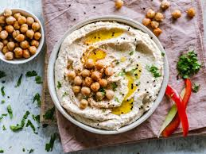
Ingredients:
Servings: 6-8

1, 15 oz. can chickpeas, rinsed and drained
2 cloves garlic, peeled
3 Tbsp tahini
1-2 Tbsp lemon juice
2 Tbsp olive oil
½ tsp ground cumin
Salt and pepper to taste
¼ cup water, or more if needed

Directions:

- Place all of the ingredients (except for water) into a food processor or blender.
- Blend until smooth. Add in water and blend until desired consistency is reached.
- Enjoy!

Interested in learning more about nutrition and health? Call the Wellness Center at 255-4444 and schedule an appointment one of our dietitians.

