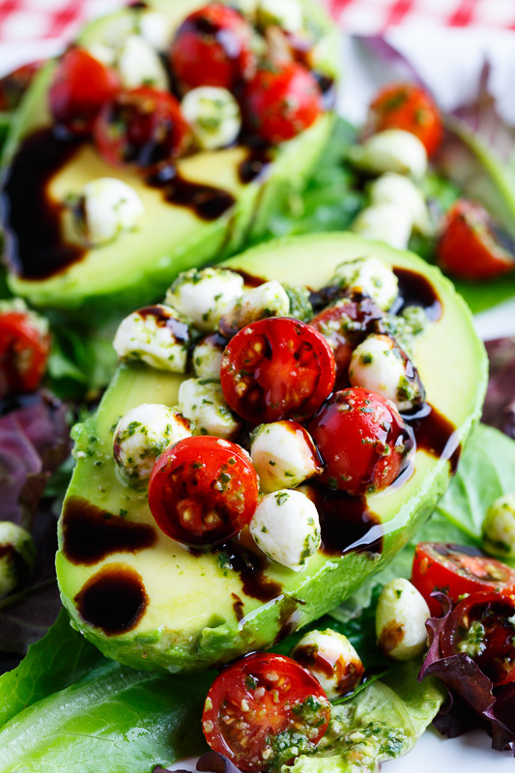
Caprese Stuffed Avocados
Avocados stuffed with fresh tomatoes and mozzarella
tossed in basil pesto and finished with a drizzle of
balsamic vinegar.

Ingredients:
Makes 4 servings

2 avocados, cut in half, stone and skins removed
1 cup salad greens
1 cup tomato, diced
½ cup fresh mozarrella, diced
2 tbsp basil pesto
2 tbsp balsamic vinegar

Nutritional info (per serving): Calories: 257, Fat: 22g, Protein: 6.5g, Carbohydrate: 11g, Fiber: 8g, Sodium: 96mg

Directions:
- To make the balsamic reduction, simmer balsamic vinegar until it reduces to ½ to ¼ or the desired thickness and let it cool before using.
- Plate the avocado on the salad greens and top with the mixture of the tomato, mozzarella and pesto followed by a drizzle of the balsamic reduction.
- Enjoy!

