Burrito Bowl Toppings

Chipotle Cream Sauce
1 cup plain Greek yogurt
1 Tbsp. chipotle paste or 2 Tbsp. chipotle peppers in adobo sauce
1 clove garlic, minced or 1 tbsp of garlic powder
Juice of 1 lime
½ tsp. salt

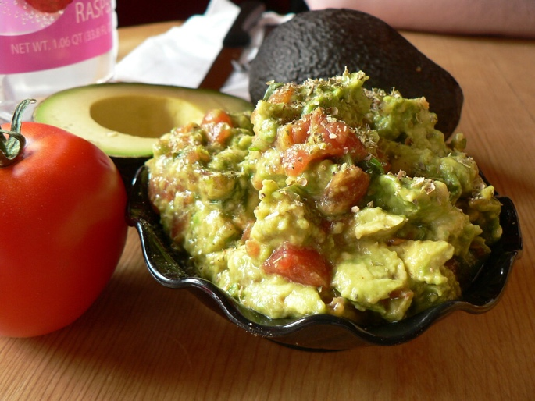
Guacamole
2 avocados, halved, deseeded and chopped
1 tsp. cumin
1 tsp. chili powder
Juice of ½ a lime
Salt and pepper to taste

