Budget Friendly Burrito Bowls

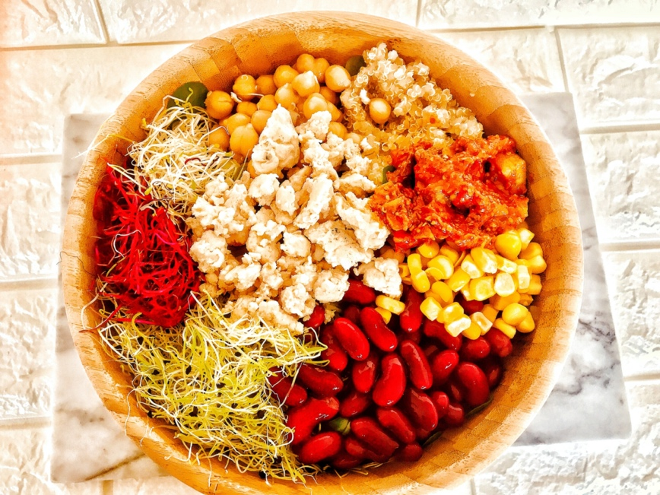
Ingredients:
Servings: 6

1 cup uncooked brown rice
1 can black beans, drained and rinsed
1 pound chicken or tofu
1 red pepper, chopped and sautéed

1 green pepper, chopped and sautéed
1 yellow onion, chopped and sautéed
2 tomatoes, diced
1 cup shredded cheese
2 cups shredded lettuce
½ cup fresh cilantro leaves (optional)
2 Tbsp. olive oil
1 tsp. cumin
1 tsp. chili powder

Directions:
- Season chicken or tofu with salt, pepper, cumin and chili powder and cook in a greased sauté pan over medium heat for about 5 minutes per side.
- Cook rice according to package instructions. When rice is done season with lime juice and chopped cilantro leaves.
- Chop and sauté peppers and onions in olive oil in a sauté pan over medium heat for about 10 minutes.
- Dice tomatoes
- Shred cheese
- Shred lettuce
- Destem and chop cilantro
- Make chipotle cream sauce by mixing all ingredients in a medium bowl.
- Make guacamole by mixing all ingredients in a medium bowl.
- Build bowl by putting rice in bowl and then topping with beans and/or chicken or tofu, sautéed veggies, lettuce, guacamole, chipotle cream sauce, tomatoes and cheese. Garnish with whole cilantro leaves.

