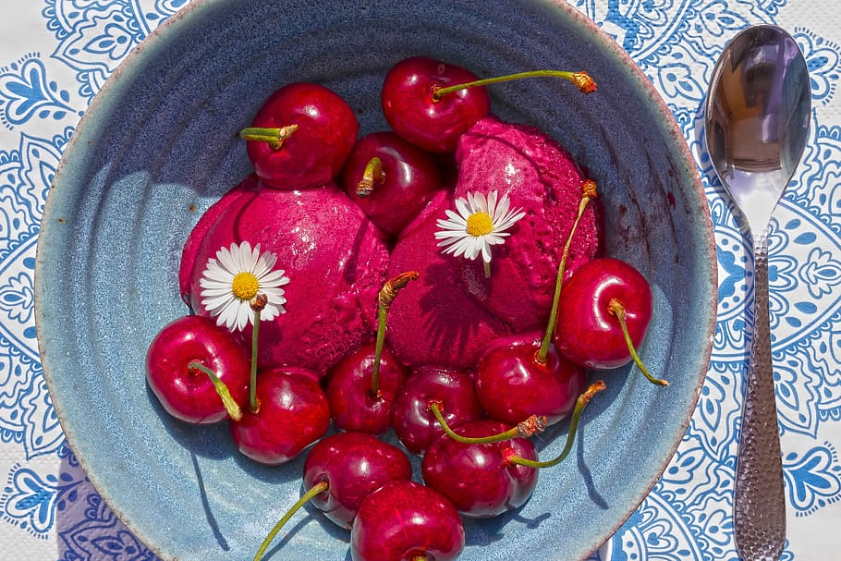

Black Cherry Sorbet

Ingredients- Yields 4 sevings:
- 2 pounds of frozen, pitted cherries
- 1 cup of water
- ½ cup of maple syrup or honey
- Lime juice (from 1 lime)

Directions:
- Place all ingredients into a blender or food processor and blend until smooth
- Enjoy! Or, store in an airtight container in the freezer. Can be stored in the freezer for up to a month!

