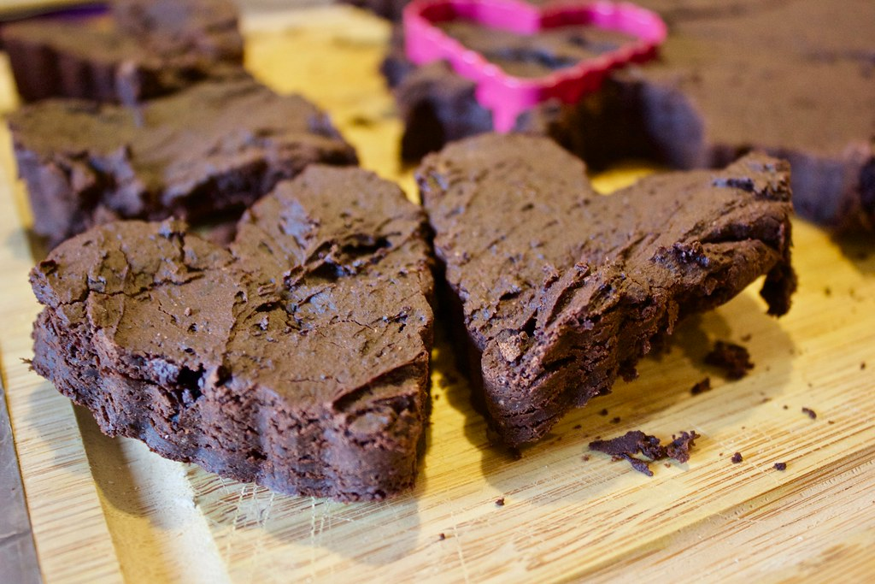

Black Bean Brownies (Vegan)
Yields: 9-12 Brownies

Ingredients:

- 1 15-oz can of black beans, rinsed and drained
- 2 tablespoons of cocoa powder
- ½ cup of quick oats
- ¼ teaspoon of salt
- 1/3 cup pure maple syrup or honey
- 2 tablespoons of sugar
- 1/3 cup of coconut or vegetable oil
- 2 teaspoons of vanilla extract
- ½ teaspoon of baking powder
- ½ cup of chocolate chips

Directions:
- Preheat oven to 350
- Mix all ingredients, except for chocolate chips, into a food processor or blender. Mix until smooth.
- Mix in Chocolate chips to batter.
- Grease an 8x8 pan or muffin tin with coconut or vegetable oil.
- Put batter in pan or muffin tin.
- Bake for 15-18 minutes.
- Let cool for 10 minutes and enjoy!

