Backyard BBQ Corn Salad

Ingredients:
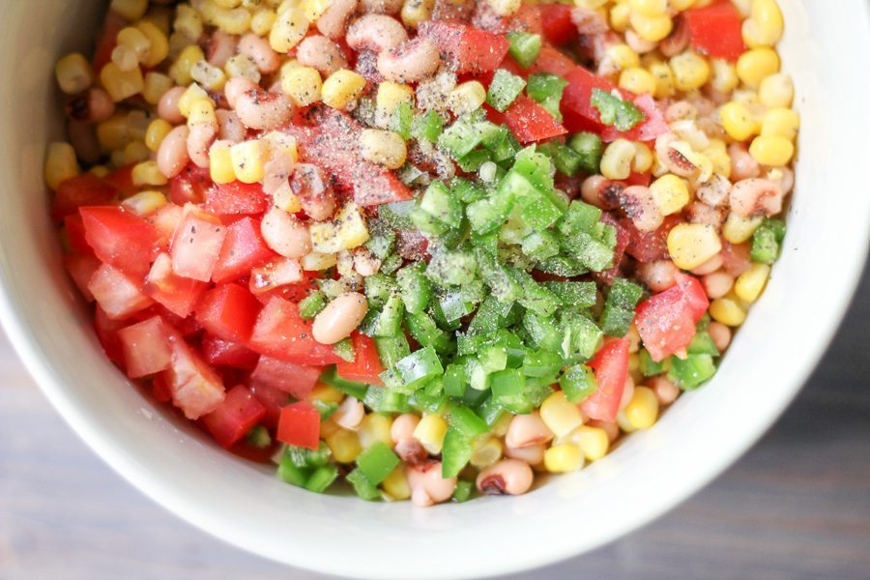
6 servings

1 large red bell pepper
15 ounces black eyed peas drained/rinsed
1 can corn drained or 3 fresh cobs
1 tomato chopped
1/4 cup chopped onion
6 tablespoons white vinegar
4 tablespoons olive oil divided
1/2 tablespoon honey
1 teaspoon minced garlic
Salt and pepper to taste

Additional Options: cilantro, jalapeno, spicy peppers, or your favorite BBQ spices!

Directions:
- Chop bell pepper in half and remove all seeds. Slice into wedges.
- Lightly brush the pepper strips with 1 tablespoon of oil. Sprinkle with salt and pepper.
- Place the pepper strips in a pan skin side down, place lid, and cook until the skin is tender and they are slightly charred. Flip them and cook other side. Remove and let cool.
- Chop onion, drain/rise beans and corn, mince garlic, and combine all other ingredients into a bowl and mix.
- Chop peppers once cool and add to mixture.
- Enjoy!

Tips: Add your favorite salad dressing to add flavor to your salad! Try chicken or tuna for adding protein.

