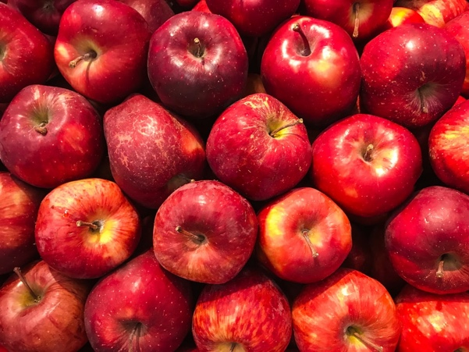
Applesauce and Yogurt Parfait with Homemade Granola

Make your own applesauce and add it to your
favorite yogurt for this fun fall recipe! Eat it for breakfast
or as a snack. You’ll get protein and calcium from the
yogurt, sweetness from the applesauce,
and a satisfying crunch from the granola!

Homemade Applesauce Ingredients: Makes about 4 servings
-3 pounds of cooking apples that are cored, peeled and cut into 1-inch chunks
-Juice from 1 lemon
-1 stick of cinnamon
-¼ cup of brown sugar
-½ cup water
-1 pinch of salt

Directions:
Combine all ingredients into a saucepan that is covered with a lid. Bring ingredients to a boil, then turn to low and simmer until the apples are completely soft (about 20 minutes).
Instant Pot Directions:
Combine the ingredients into the instant pot and mix. Close the lid and pressure cook on high for 5 minutes. Natural release for 10 minutes, remove lid, stir, mash with a potato masher if necessary and enjoy!

Homemade Granola Ingredients: Makes about 4 servings
-2 cup rolled oats
-2 tablespoons brown sugar
-½ teaspoon ground cinnamon
-¼ teaspoon salt
-⅓ cup of honey
-3 tablespoons of coconut oil
-½ teaspoon vanilla extract
-½ cup chopped nuts, dried fruit, or seeds

Directions:
Heat coconut oil in large pan over medium heat. Combine the oats, sugar, cinnamon, honey and vanilla extract in pan and stir constantly for 3-4 minutes. Remove from heat, stir in nuts/seeds/dried fruit and allow to cool.

