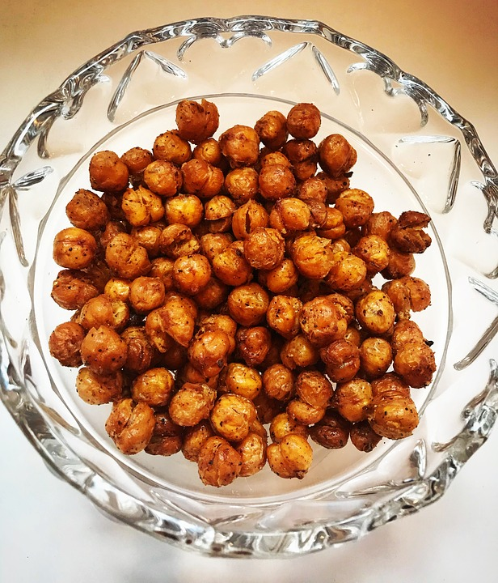

Roasted Chickpeas

Ingredients:
- 1 16 oz. can of chickpeas
- 2 tablespoons of olive oil (or oil of your choice)
- A pinch of salt
- A pinch of garlic
- A pinch of cayenne pepper

Instructions:
- Wash your hands!
- Preheat oven to 450 degrees fahrenheit. Place parchment paper onto baking pan.
- Rinse chickpeas and blot try with towel (make sure they are dry!)
- Mix in a bowl with olive oil and seasonings.
- Spread chickpeas out on parchment paper.
- Bake for about 30 minutes or until crispy!
- Enjoy!

