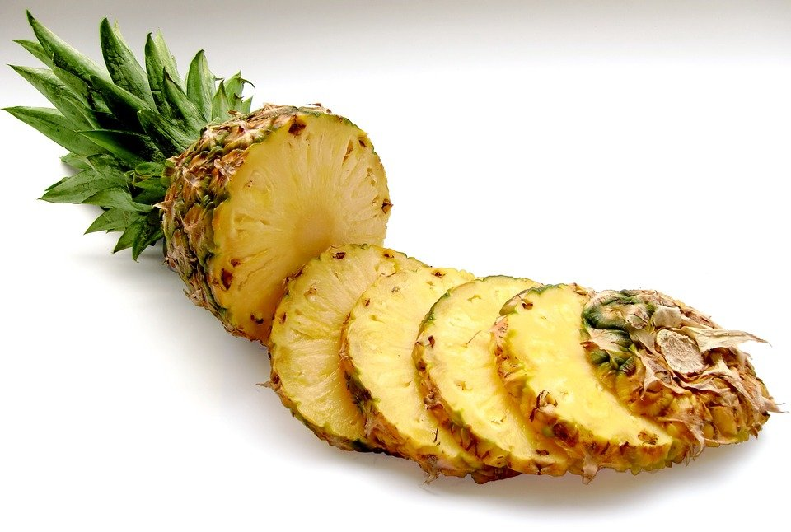
Homemade Tropical Fruit by the Foot

Ingredients:

- 1 pineapple, chopped and cored.
- 1 mango, peeled and chopped.
- 1 tablespoon of honey
- Juice from 1 lemon

Instructions:
- Preheat the oven to 200 degrees. Line a large baking sheet with parchment paper.
- Put the ingredients into the blender and blend until smooth.
- Pour the mixture onto the baking sheet and spread it out into an even layer.
- Bake for 4-5 hours or until the center is no longer tacky.
- Remove and let cool.
- Cut into strips and roll it up.
- Enjoy! Store in an airtight container for up to 7 days.

