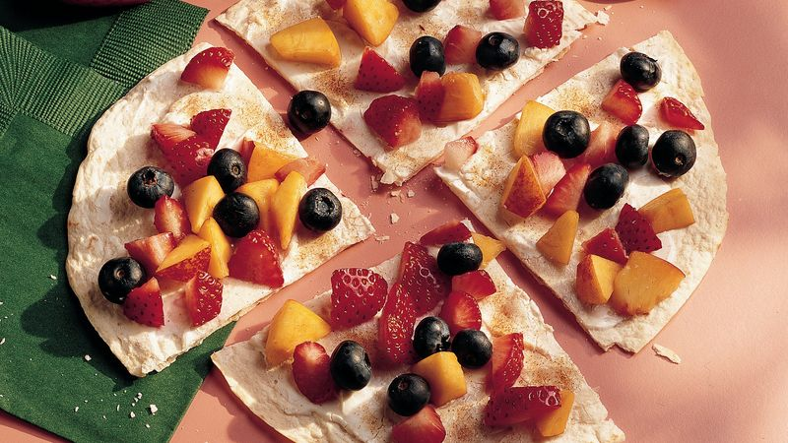

Fruit Pizza

Ingredients:
- 1 corn or wheat tortilla
- 1-2 tablespoons of Greek yogurt
- Fruit of your choice

Instructions:
- Wash your hands!
- Spread yogurt onto tortilla
- Add fruit into a pattern of your choice.
- Cut into triangles, enjoy!
- Experiment with spices such as cinnamon if you wish

