5 Ingredient Energy Bites

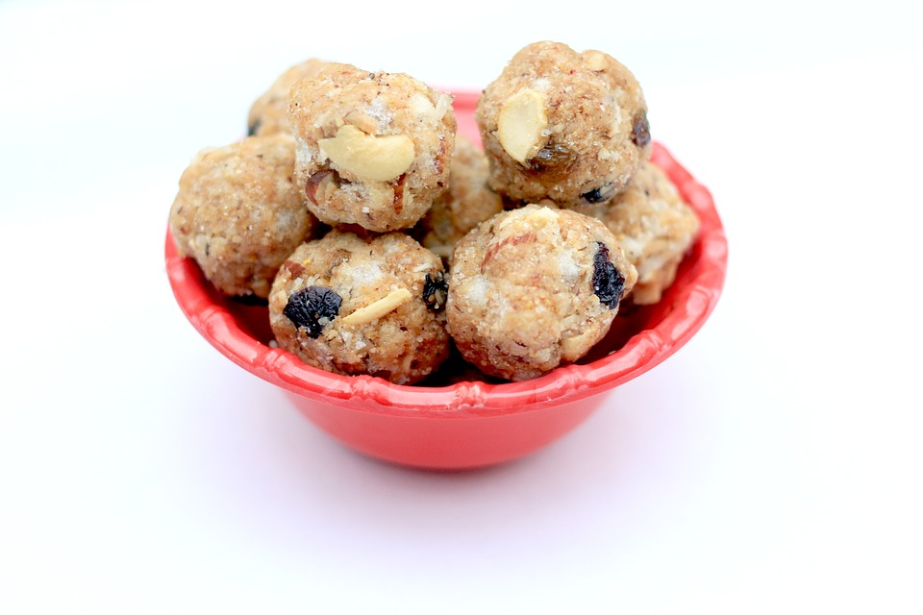
Ingredients:
Makes 12 bites

1.5 c oats, dry
1/3 c honey (or maple syrup)
1/2 c peanut butter
1/3 c dried cranberries
1/3 c crushed walnuts

Directions:
- In a bowl, stir all ingredients together until mixed well
- Roll mixture into balls, about 1” in diameter (golf ball size)
- Store in airtight container in refrigerator for up to 1 week
- Substitute with different nut butters and dried fruits! Add dark chocolate for some extra sweetness or chia/flaxseeds for extra fiber!

Interested in learning more about nutrition and health? Call the Wellness Center at 255-4444 and schedule an appointment with one of our dietitians.

